1.5

1)

CREATE TABLE supply (   
supply_id INT PRIMARY KEY AUTO_INCREMENT,  
title VARCHAR(50),  
author VARCHAR(30),  
price DECIMAL(8, 2),  
amount INT  
)  
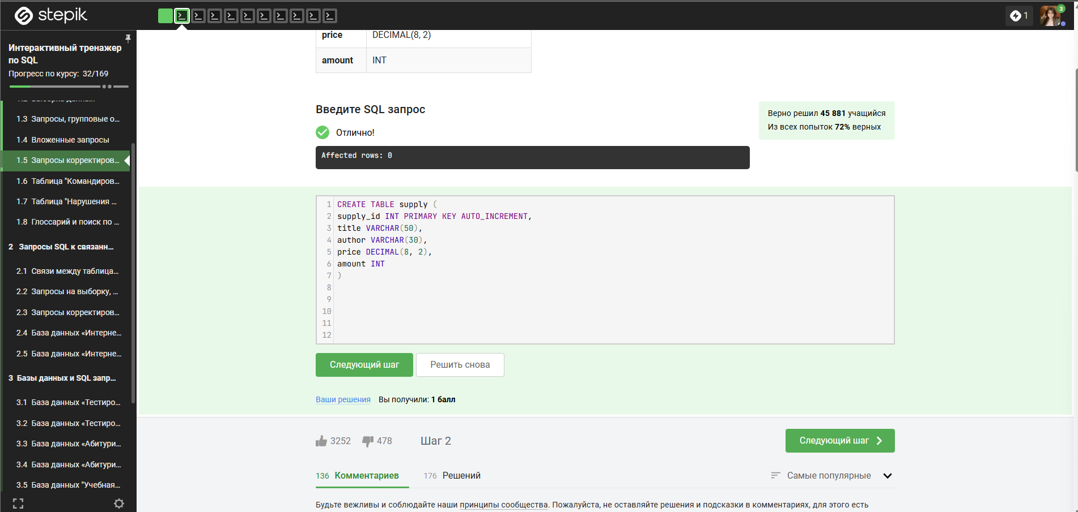

2)  
INSERT INTO supply (title,author,price,amount)  
VALUES ('Лирика','Пастернак Б.Л.',518.99,2),  
('Черный человек','Есенин С.А.',570.20,6),  
('Белая гвардия','Булгаков М.А.',540.50,7),  
('Идиот','Достоевский Ф.М.',360.80,3)  
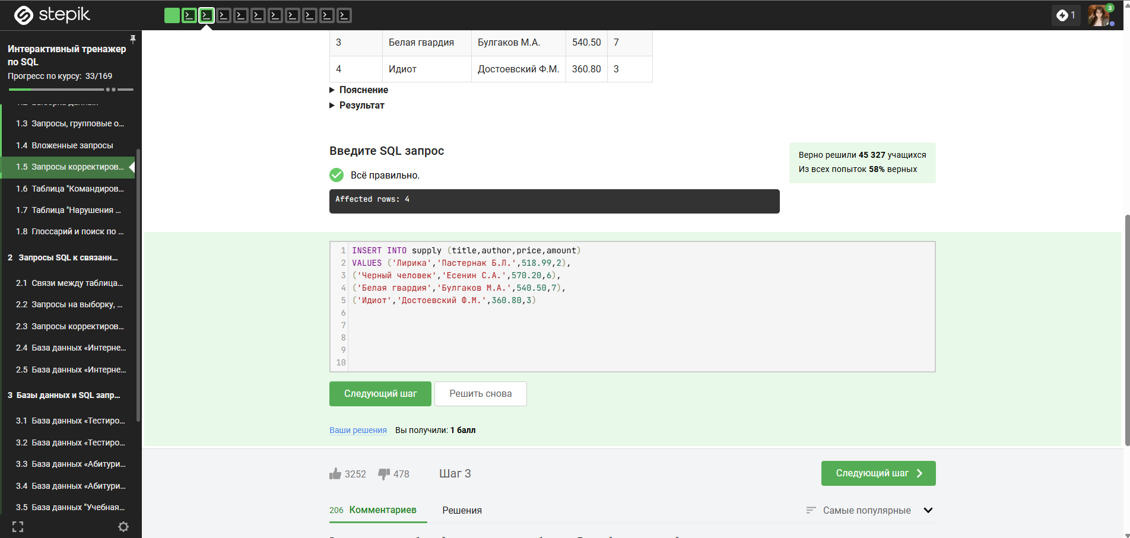

3)  
INSERT INTO book (title, author, price, amount)  
SELECT title, author, price, amount   
FROM supply  
WHERE author NOT IN ('Булгаков М.А.', 'Достоевский Ф.М.');  
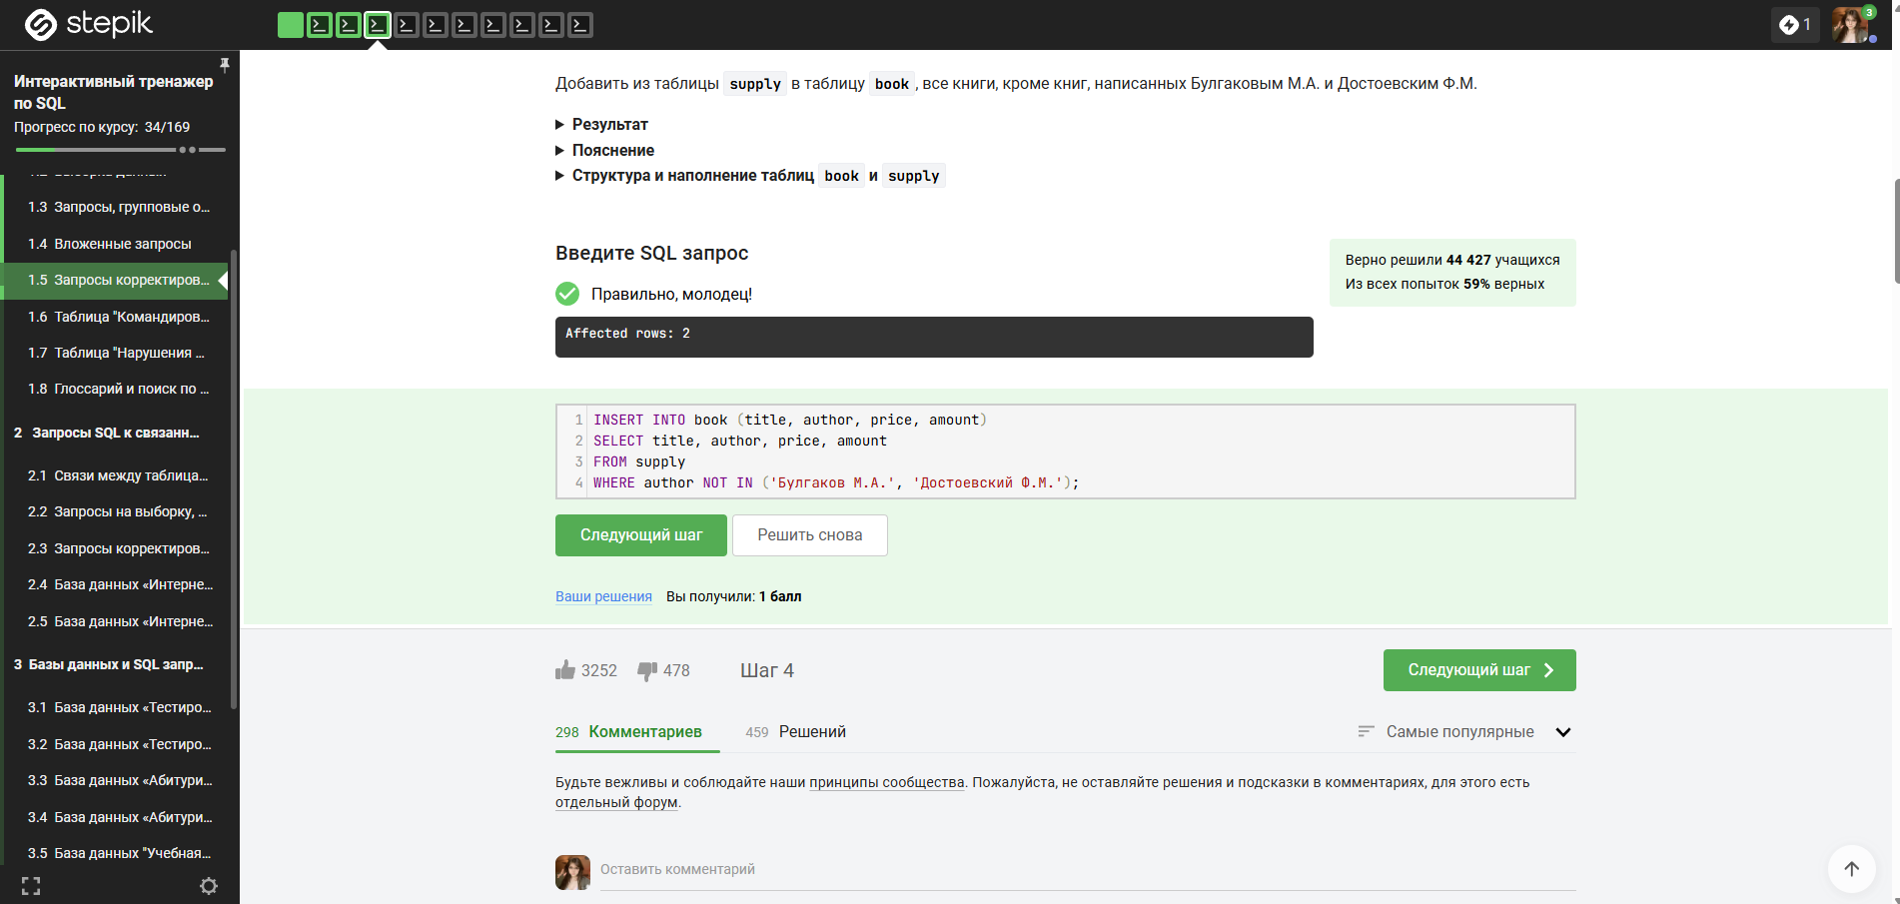

4)  
INSERT INTO book (title, author, price, amount)  
select title, author, price, amount   
from supply  
where author not in (select author from book)  
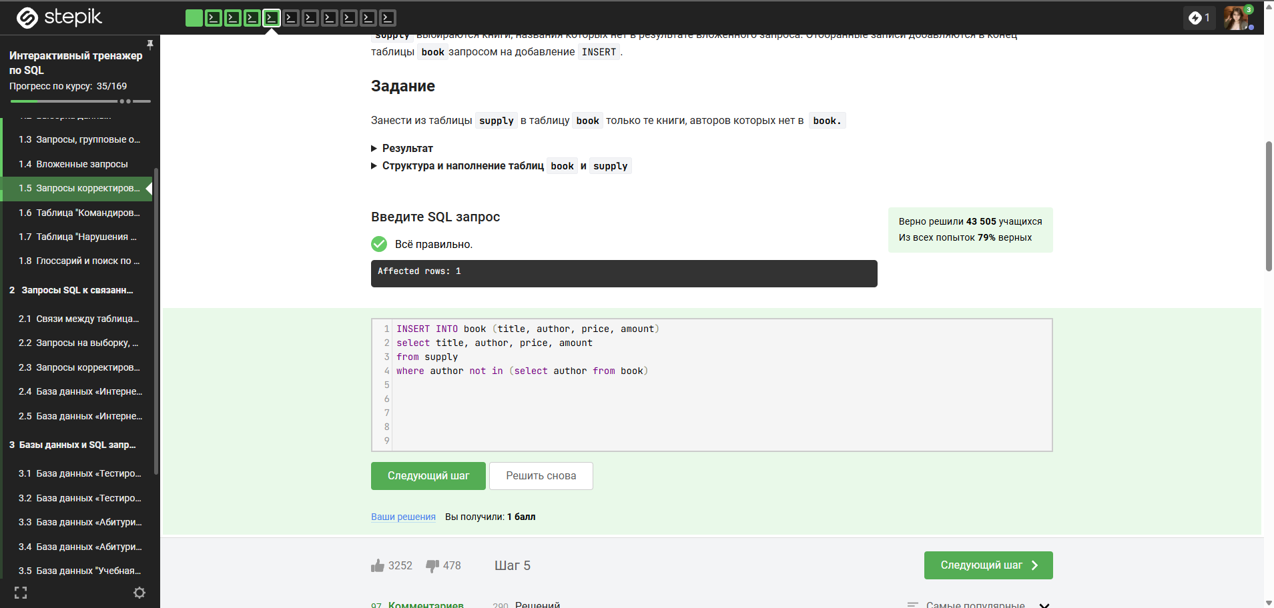

5)  
UPDATE book   
SET price = price * 0.9  
where amount between 5 and 10;  
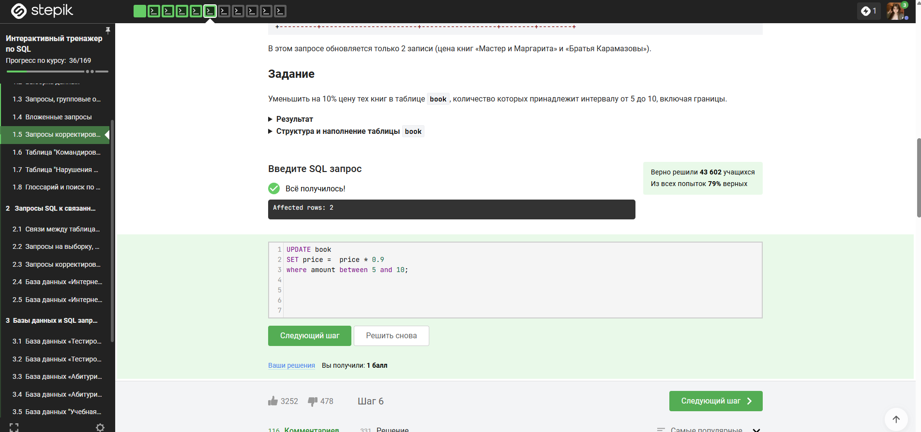

6)

UPDATE book   
SET   
buy = LEAST(buy,amount),  
price = CASE  
WHEN buy = 0 THEN price * 0.9  
ELSE price  
END;  
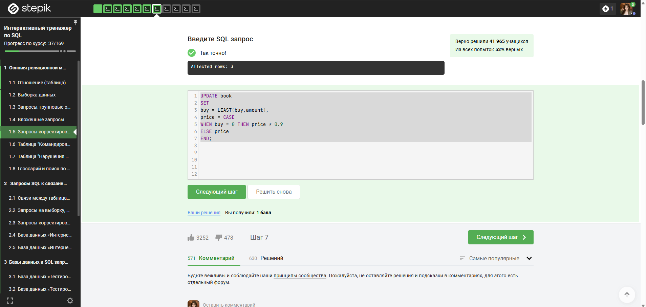

7)  
UPDATE book  
JOIN supply ON book.author = supply.author AND book.title = supply.title  
SET   
book.amount = book.amount + supply.amount,  
book.price = (book.price + supply.price) / 2;  
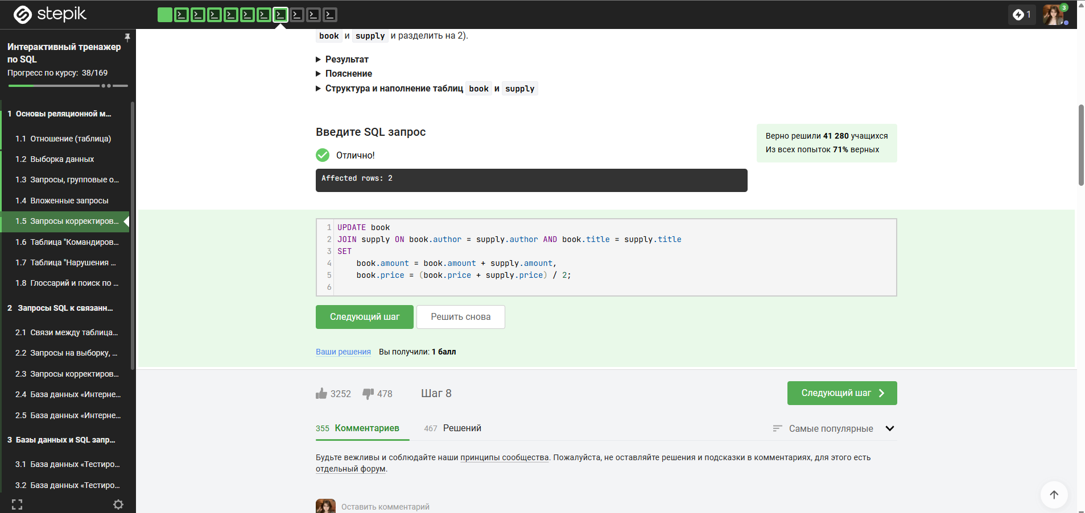

8)  
DELETE FROM supply  
WHERE author in (  
 SELECT author   
 from book   
 group by author   
 having sum(amount) > 10  
);  
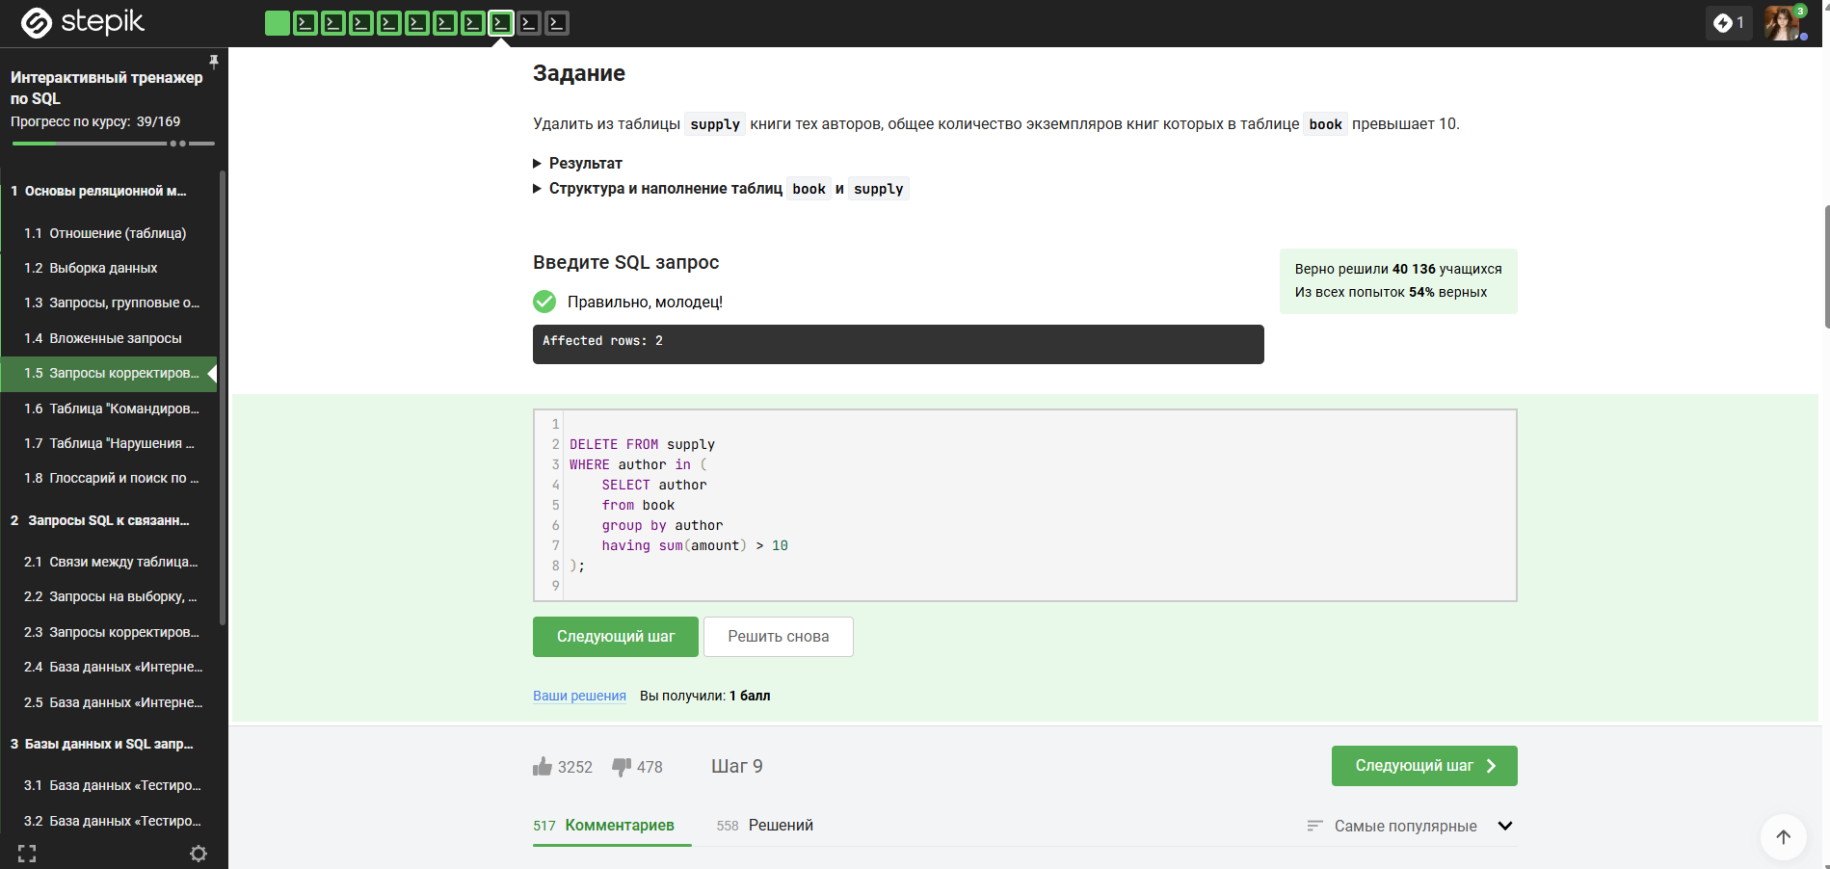

9)  
CREATE TABLE ordering as  
SELECT author,title,  
(select round(avg(amount),2) from book)  
from book  
where  
amount < (select avg(amount) from book)  
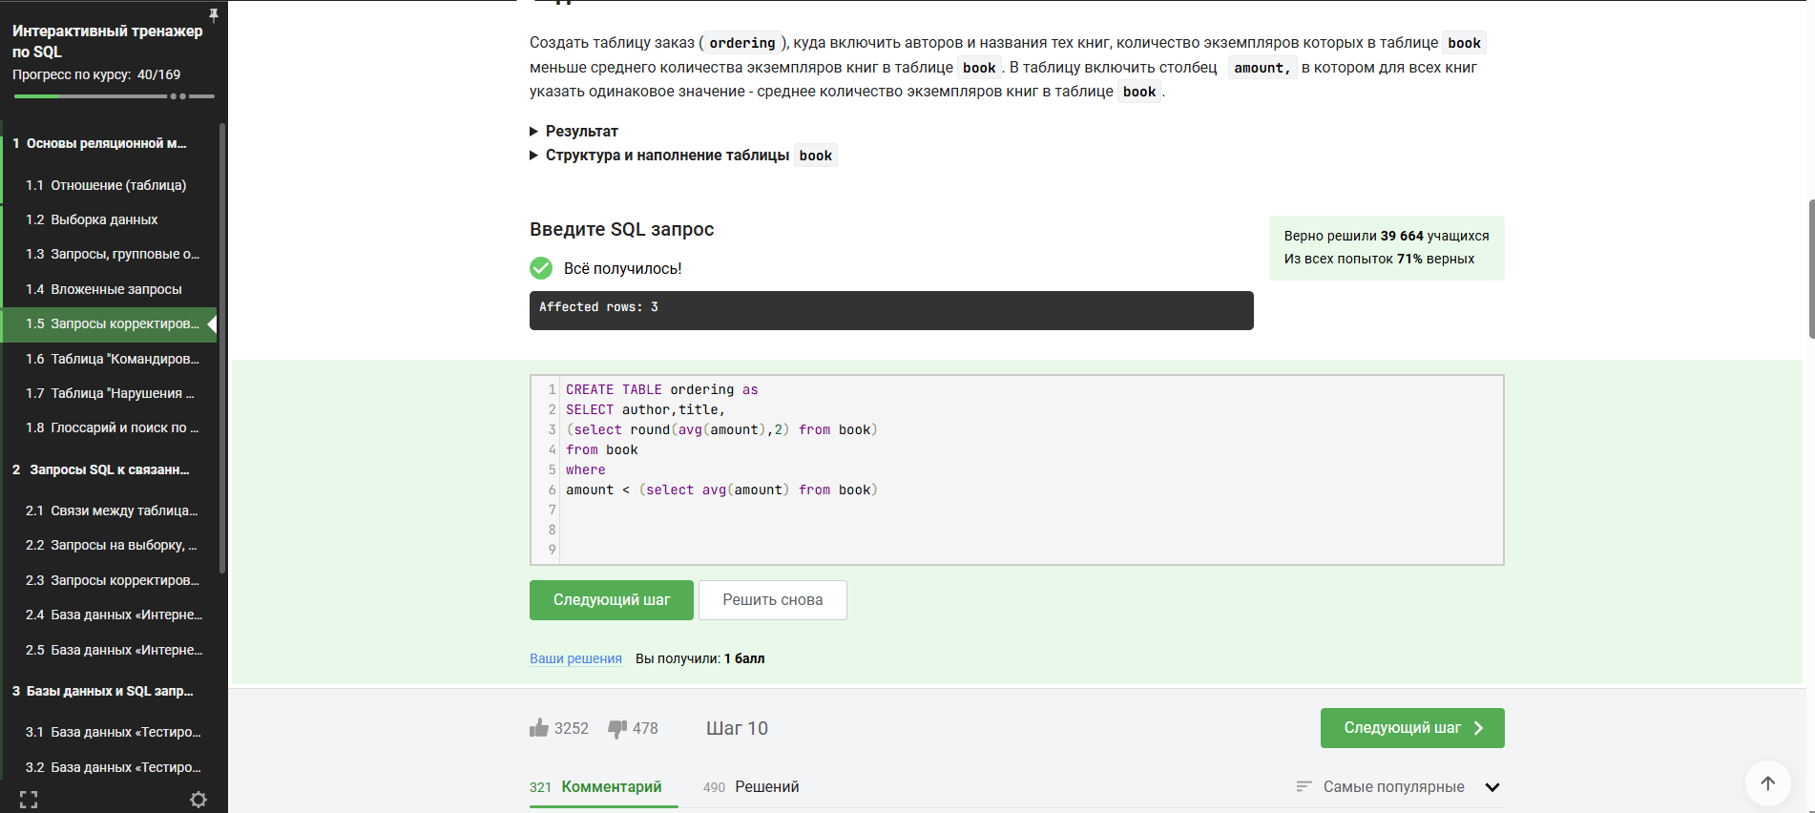

10)  
CREATE TABLE my as  
SELECT supply.title,supply.author  
from supply,book  
where supply.author = book.author  
